Impossible to Save your Session Error MC75:
(Error 100054)
This error normally just needs a Handheld re-boot.
*****Important***** do not cancel your activity. Once you reboot the handheld and log back into Scannabar you will resume where you left off. No Data will be lost.
- Reboot your MC75 Handheld Scanner. There are 2 ways to Reboot the Handheld.
  - 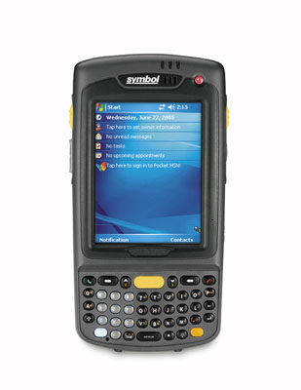
Hold Down the red On/Off button in the top right hand corner for 5 to 10 seconds until the Screen shows MC75 Warm Boot. Once it reboots try Logging into Scannabar.
If that did not Fix your Error you can now Try a Cold Re-Boot of the MC75.
Do this by holding down the red On/Off button in the top right, and the number 1 & 9 on the Keyboard. All buttons must be pressed down at the same time.

Log back into your Scannabar software and you should be right where you left off. If your session was over just click save and your session should save.
If this did not resolve your problem please call one of our Solutions providers@1-800-939-8960 Ext: 2

