Network Hasn’t Responded for 15 Seconds MC75:

First thing you would like to check is your Terminal ID:
- Clik on the Scannabar icon on the Handheld.

2. Then click on the square with the 3 dots next to terminal default.
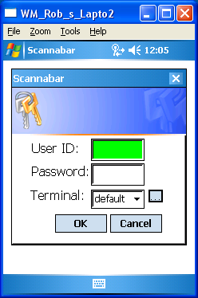

- In the new Screen Highlight your Terminal name and Click the Edit Button.
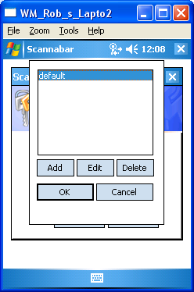

- In this screen the only field you need to verify the Terminal field. Leave all other fields as is
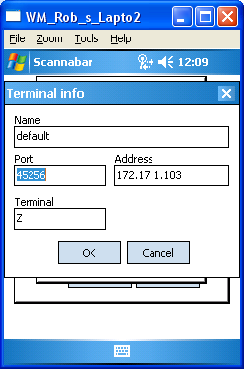

- Make sure the Terminal is a Capital Z. This is the default setting.

- Once the change has been made. Click Ok, and Ok again.

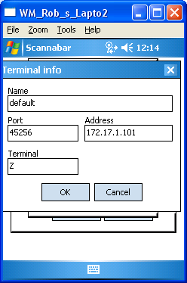

- You should now be able to log into your Handheld Scanner.

If this did not resolve your problem please move onto the next solution.

Now you will need to Verify your Wireless Signal Strength.

- Perform a Warm Re-Boot of the Handheld.
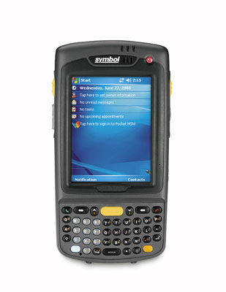
Hold Down the red On/Off button in the top right hand corner for 5 to 10 seconds until the Screen shows MC75 Warm Boot. Once it reboots try Logging into Scannabar.

- Once your Handheld has rebooted. Click on the Wireless Icon and in the bottom right hand corner of the touch screen click on Fusion Menu.
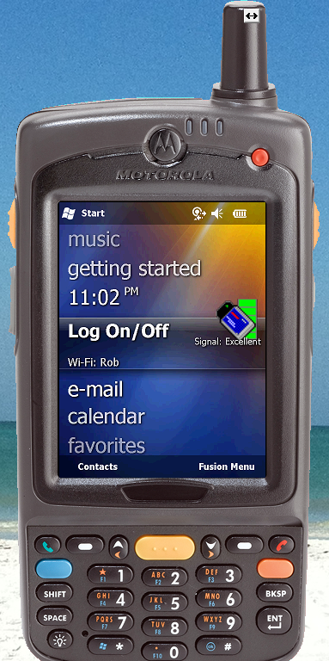

- Click on the Wireless Status selection.
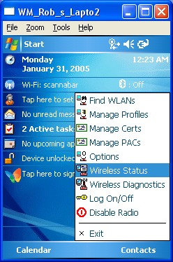

- Now in this screen you will need to Verify Signal Strength.
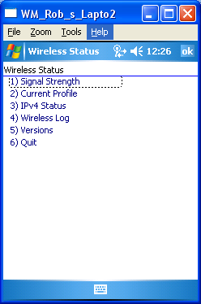
  - To verify signal strength. Walk to your closest wireless Antennas you should see full green bars here.
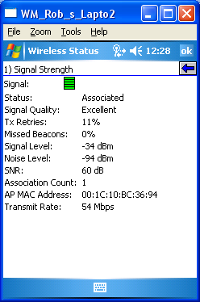

If you do not see this please unplug and re-plug the electrical power to the antennas.

If all else fails Re-boot the Scannabar Back office PC and see if that resolves your issue.

If this did not resolve your problem please call one of our Solutions providers@1-800-939-8960 Ext: 2

