TCPIP Error 100060 MC75:

This Error is usually Related to Signal Strength and Network problems. Try these solutions to Solve your Problem.

- Reboot your MC75 Handheld Scanner. There are 2 ways to Reboot the Handheld.
  - 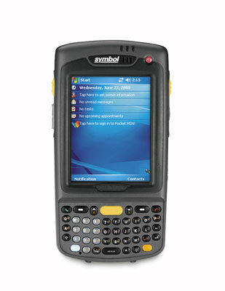
Hold Down the red On/Off button in the top right hand corner for 5 to 10 seconds until the Screen shows MC75 Warm Boot. Once it reboots try Logging into Scannabar.

If that did not Fix your Error you can now Try a Cold Re-Boot of the MC75.
Do this by holding down the red On/Off button in the top right, and the number 1 & 9 on the Keyboard. All buttons must be pressed down at the same time.

If this did not resolve your problem please move onto the next solution.
You will now need to Check your Wireless Status to make sure you have a Wireless Connection and an IP address.

- Perform a Warm Re-Boot of the Handheld.
Hold Down the red On/Off button in the top right hand corner for 5 to 10 seconds until the Screen shows MC75 Warm Boot. Once it reboots try Logging into Scannabar.

- Once your Handheld has rebooted. Click on the Wireless Icon in the bottom right hand corner of the touch screen.
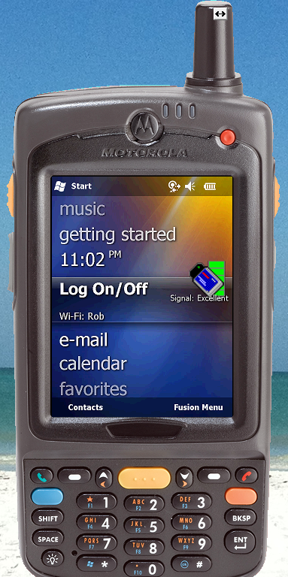

- Click on the Wireless Status selection.
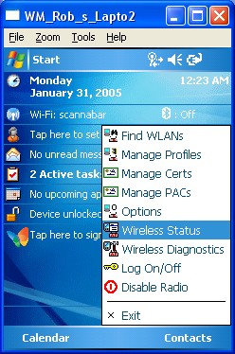

- Now in this screen you will need to Verify 2 things. Signal Strength and IPv4 Status.
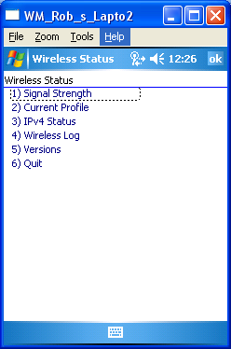
  - First we will verify signal strength. Walk to your closest wireless Antennas you should see full green bars here.
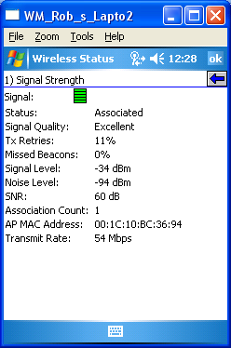

If you do not see this please unplug and re-plug the electrical power to the antennas.
  - Once you have your signal strength the second thing to verify we have a proper IP address.
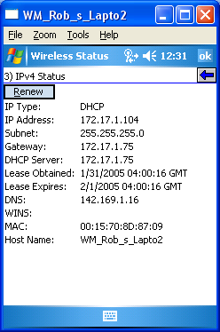

What we are looking for here is weather we have a Static or DHCP address. Once we see that we should see an address populate the IP address field. If you see 0.0.0.0 then you are not properly setup on your network and will need to contact your Network administrator to setup your Handheld Scanner.

Please note Scannabar cannot aid you on this matter unless you have spoken to or are the person who setup the Wireless network.
Information Scannabar would need to help you on this matter are:
SSID (network name)
Encryption Security code
IP Address of the Handheld Scanner, Host PC and Network.

If this did not resolve your problem please move onto the next solution.

Now you will need to check the IP address under your Scannabar program on the Handheld. This must match the IP address on your Scannabar PC.

First lets check for your PC’s IP address.

- Click on the Windows Start Button in the bottom left of your PC.

- Click on the Run button:
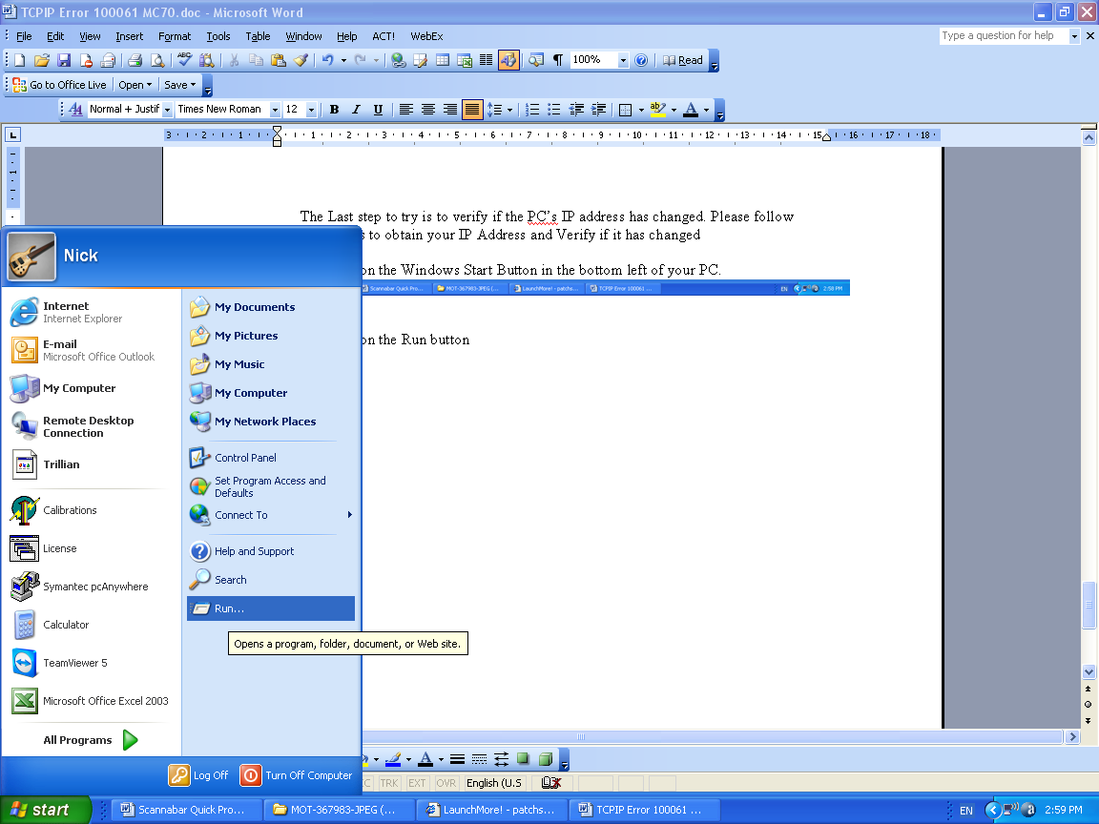

- The Run box should open up. In the Open field type CMD or COMMAND and click OK
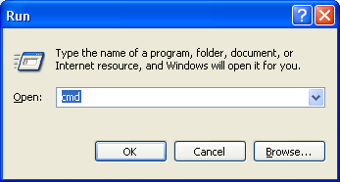

- This will open a Dos screen. In the Dos Screen type the word IPCONFIG and press the ENTER button.
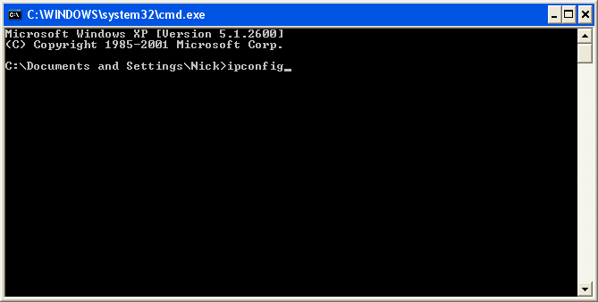

- This will now display the IP address currently assigned to your PC. Write this down. In this example we have an IP of 172.17.1.101
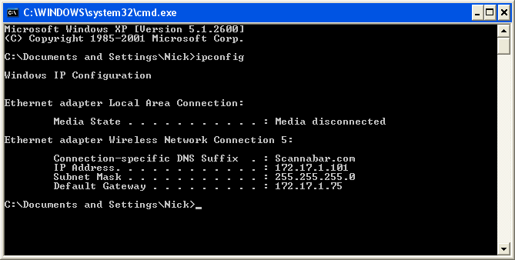

- You must now check on the handheld software to make sure this number matches up. Go to the Scannabar icon on your Handheld Scanner. Click on the Square with the 3 points next to Terminal
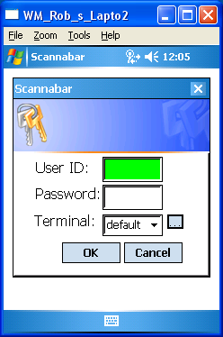

- In the new Screen Highlight your Terminal name and Click the Edit Button.
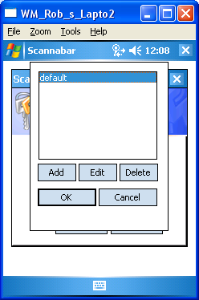

- In this screen the only field you need to verify or change is the Address field. Leave all other settings as they are.
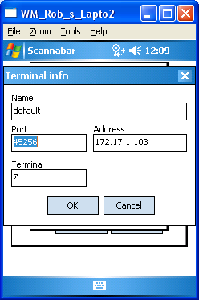

- Make sure the Address field matches the PC IP we obtained earlier. If they do not please make the necessary changes. In this example we see the address as 172.17.1.103 and or PC was 172.17.1.101.

- Once the change has been made. Click Ok, and Ok again.

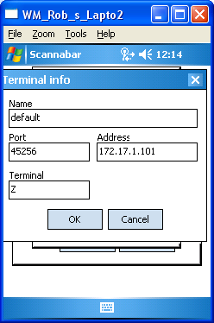

- You should now be able to log into your Handheld Scanner.

If this did not resolve your problem please move onto the next solution.
One last thing you can check is that your Windows Firewall is not on. In this Example I am using Windows XP, but it will be similar on Vista and Windows 7.

- Click on the Windows Start Button in the bottom left of your PC.

2. Click on Control Panel
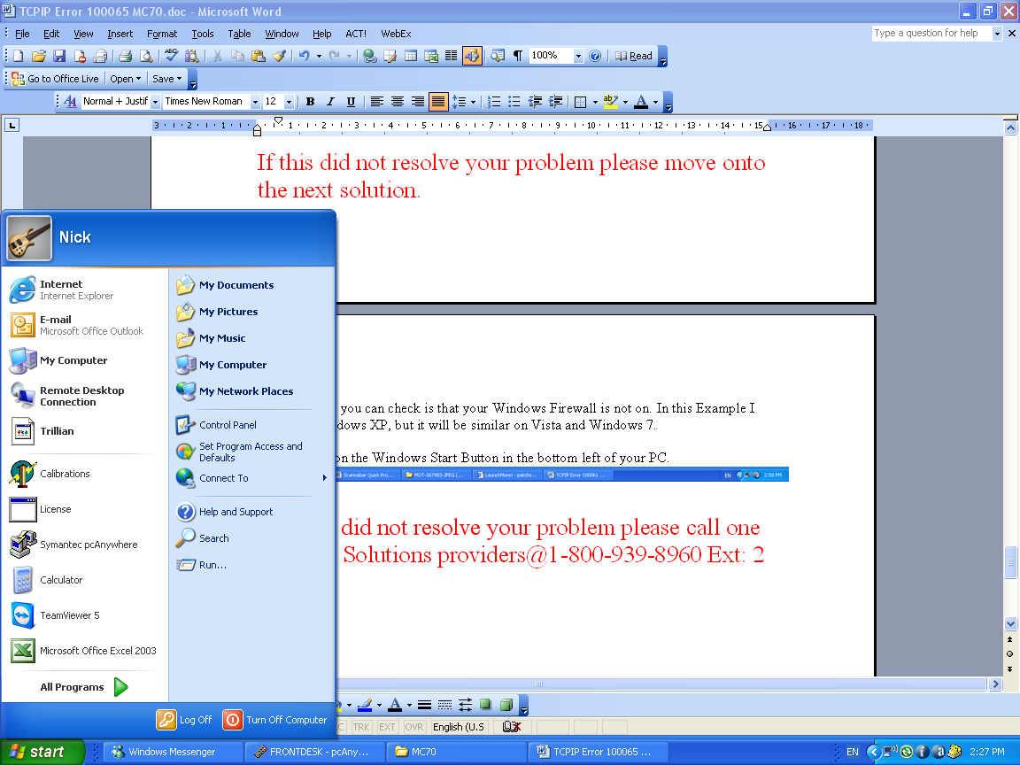

- Click on the Windows Firewall Icon.
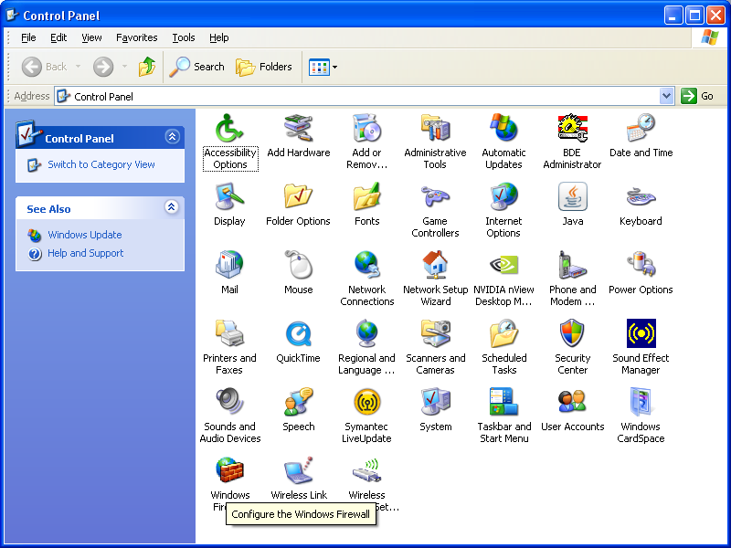

Make sure you are in Classic View.

- Now in this window make sure the Radio Button is at Off.

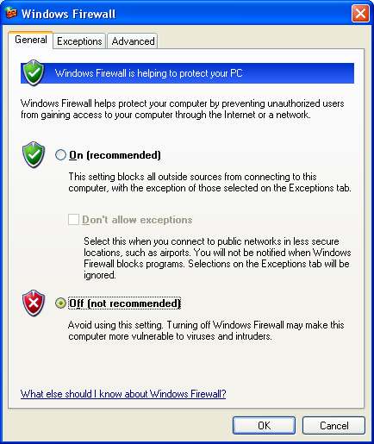
Now close the windows and try to log into you Handheld Scanner.

If this did not resolve your problem please call one of our Solutions providers@1-800-939-8960 Ext: 2

