TCPIP Error 100049 Host Name Failed MC75:

This error occurs if the Address under the Scannabar terminal does not match the one on the PC.
- Clik on the Scannabar icon on the Handheld.

2. Then click on the square with the 3 dots next to terminal default.
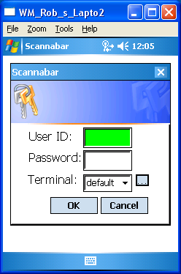

- In the new Screen Highlight your Terminal name and Click the Edit Button.
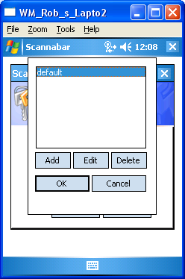

- In this screen the only field you need to verify or change is the Address field. Leave all other settings as they are.
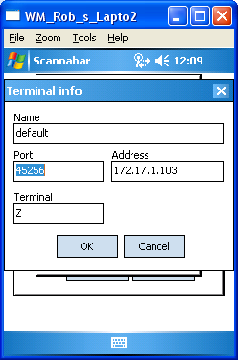

- Make sure the Address field matches the PC. If they do not please make the necessary changes. In this example we see the address as 172.17.1.103 and or PC was 172.17.1.101.

- Once the change has been made. Click Ok, and Ok again.

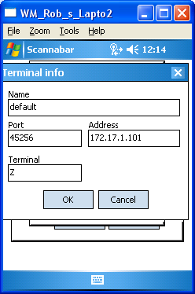

- You should now be able to log into your Handheld Scanner.

If you do not know how to btain your PC’s IP address follow these steps.

- Click on the Windows Start Button in the bottom left of your PC.

- Click on the Run button:
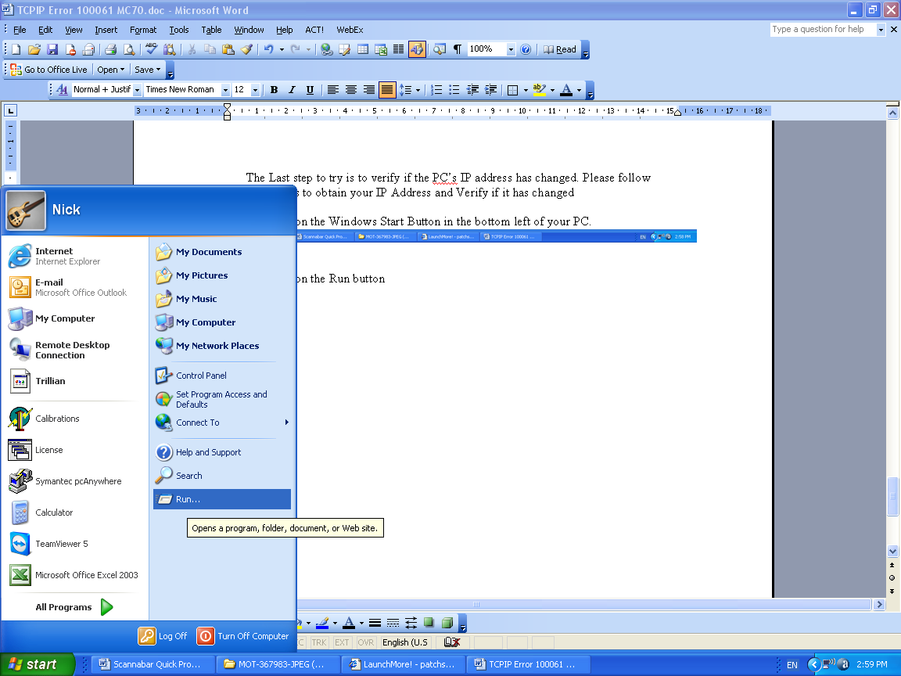

- The Run box should open up. In the Open field type CMD or COMMAND and click OK
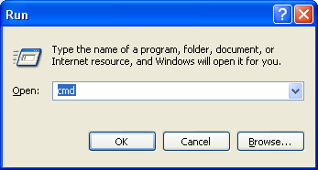

- This will open a Dos screen. In the Dos Screen type the word IPCONFIG and press the ENTER button.
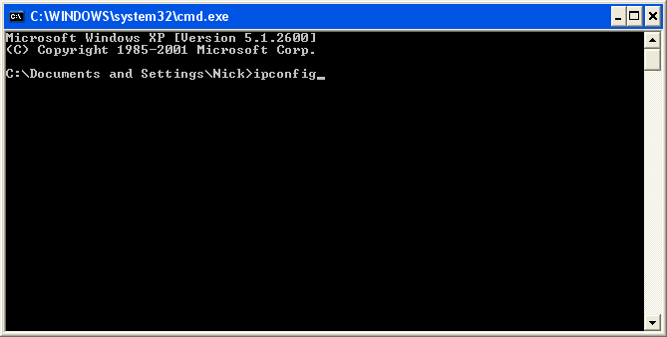
- This will now display the IP address currently assigned to your PC. Write this down. In this example we have an IP of 172.17.1.101
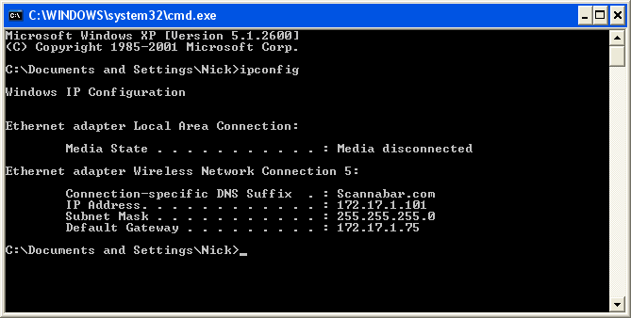

If this did not resolve your problem please call one of our Solutions providers@1-800-939-8960 Ext: 2

